Media release, 25 June 2021

Media corner at www.swissdeluxehotels.com/de/media

Swiss Deluxe Hotels – meeting the crisis with innovation, confidence and new partners

Swiss Deluxe Hotels issues its own credit card and launches a loyalty programme

Outlook for 2021 cautiously optimistic

Audi Switzerland and Netjets are new official partners of Swiss Deluxe Hotels

Michael Smithuis, President of Swiss Deluxe Hotels:
“We are very pleased to be able to hold a physical Annual General Meeting again after 18 months. Being able to engage in direct exchange with our 39 members is of immense importance and is something we have sorely missed over recent months.
The further easing of restrictions by the federal government has given us reason to see much better prospects for both national and international guests in the coming months, and, generally speaking, we are cautiously optimistic about this year's summer season.”

Zurich, 25 June 2021 – In 2020, Swiss Deluxe Hotels – the Group of the 39 most exclusive 5-star hotels in Switzerland – suffered a massive decline in overnight stays as well as in total turnover. The Group is thus now facing the biggest crisis since the founding of the association in 1934 with creativity, innovation and perseverance. The Annual General Meeting on 24 June 2021 in Lugano saw, among other things, the presentation of two new official partners as well as discussions of scenarios for the future.

For 2020, Swiss Deluxe Hotels recorded a total of 729,139 overnight stays, representing a decline of 42.2 per cent, although the months of January (+4.7%) and February (+10.7%) were very much on the up. The overall market of the hotel industry in Switzerland ended the global crisis year on a similar note – namely with minus 40.0 per cent – while the comparison group of all 5-star hotels in Switzerland suffered even more, recording a minus in overnight stays of 47.2 per cent. The total turnover of the group with all its affiliated companies slumped by 28 per cent to around CHF 1.14 billion.

Swiss domestic market has increased and now has 52% market share
Due to international travel restrictions, Swiss Deluxe Hotels recorded an overall increase of over 6 per cent in bookings from domestic guests, which corresponds to 52 per cent of the total market share.

¹ United Arab Emirates, Saudi Arabia, Qatar, Kuwait, Bahrain and Oman
² Japan, Taiwan, Hong Kong, Thailand, Singapore, Indonesia, Korea, Malaysia, Philippines, rest of South, East and West Asia
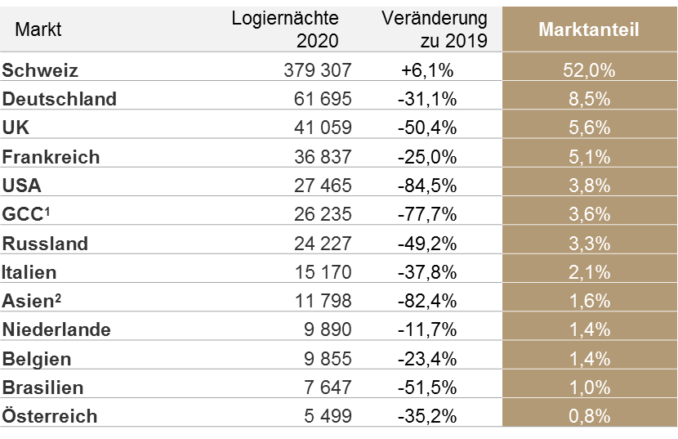

2 United Arab Emirates, Saudi Arabia, Qatar, Kuwait, Bahrain and Oman
3 Japan, Taiwan, Hong Kong, Thailand, Singapore, Indonesia, Korea, Malaysia, Philippines, rest of South, East and West Asia

Audi Switzerland and Netjets new official partners
The new partnerships are a sign of optimism and belief in the future of the luxury hotel industry in Switzerland. Audi Switzerland and Netjets are new official partners of Swiss Deluxe Hotels, combining their offer to make a perfect super-class mobility and hotel experience. “Strong brands complement each other to form a perfect whole”, says Michael Smithuis, President of Swiss Deluxe Hotels and General Manager at the Fairmont Le Montreux Palace in Montreux. “In this respect, we are very proud to be starting the future together with Audi and Netjets in an innovative way, jointly designing the best offers for our guests”.

Proprietary credit card – “Swiss Deluxe Hotels Visa Prestige”
As a further innovative step, Swiss Deluxe Hotels is launching its own credit card – the “Swiss Deluxe Hotels Visa Prestige”. The card can be used to make cashless payments worldwide and, with every payment, the user collects bonus points for which there are attractive value vouchers in the 39 Swiss Deluxe Hotels. An exclusive concierge service rounds off the offer. “The launch of our own credit card is another milestone in the quest to strengthen and raise awareness of our brand”, says Managing Director Jan E. Brucker.
The card came about in collaboration with the BonusCard division of Cornèr Bank AG in Zurich. “Together we have developed an attractive payment card with many privileges for a discerning clientele. We are convinced that hotel guests will use their card enthusiastically and redeem their accumulated bonus points for further stays at their favourite hotels”, explains Max Nunziata, Director of Cornèr Bank AG, BonusCard branch office (Zurich).
www.swissdeluxehotels.com/visa

Summer edition of the H Magazine
The Swiss Deluxe Hotels Magazine in its new format is appearing for the third time this summer. The focus is on the destination of Gstaad and all its facets, making for a perfect mountain summer in beautiful Saanen. Well-known journalists report from the Swiss Deluxe Hotels, where the subject of sustainability is also increasingly coming into focus. This summer the magazine will be available in all Globus branches from 1 July 2021 and naturally will continue to be available online as a blog and flip book on the Swiss Deluxe Hotels website.

Swiss Deluxe Hotels

The Swiss Deluxe Hotels association (SDH) was founded in 1934 and comprises 39 of the most renowned 5-star hotels in Switzerland such as The Dolder Grand and the Baur au Lac in Zurich, the Victoria-Jungfrau Grand Hotel & Spa in Interlaken, the Gstaad Palace, the Beau-Rivage Palace in Lausanne, Badrutt’s Palace Hotel and the Kulm Hotel in St. Moritz, the Castello del Sole in Ascona and the Grand Hotel Les Trois Rois in Basel. They all embody the prestige of the Swiss luxury hospitality sector, to which they have contributed so successfully for almost two centuries. With a total of 4,100 rooms and suites and some 8,200 beds, the SDH's membership accounts for more than 40 per cent of Switzerland's 5-star capacity. The SDH is thus the most important association in this segment and has for decades assumed a leading role in Switzerland's luxury hospitality. The name Swiss Deluxe Hotels stands for exclusive quality and the highest standards. The personal service is unique: over 8,000 employees ensure the well-being of a clientele accustomed to service luxury. In 2020, the Group recorded around 730,000 overnight stays, while annual sales in 2020 totalled around CHF 1.14 billion.

The figures are partly based on extrapolations of the entire group of 39 Swiss Deluxe Hotels in 2020.

Further information:

Evelyn Gorgos
Head of Corporate Communications and Media Relations
Swiss Deluxe Hotels
Augustinergasse 30, 8001 Zurich
gorgos@swissdeluxehotels.com
T +41 43 243 71 40
M +41 78 677 93 07

